**Assignment 2**

**Linux Basic Commands Assignment**

1. Create a file like nano file1.txt

o Edit some data and then save the file

Solution:

1. Type command nano file1.txt
2. Write the line “I am writing in nano text editor” in file1.txt
3. Ctrl + x
4. Then press y to save file1.txt
5. Hit enter to exit from the editor

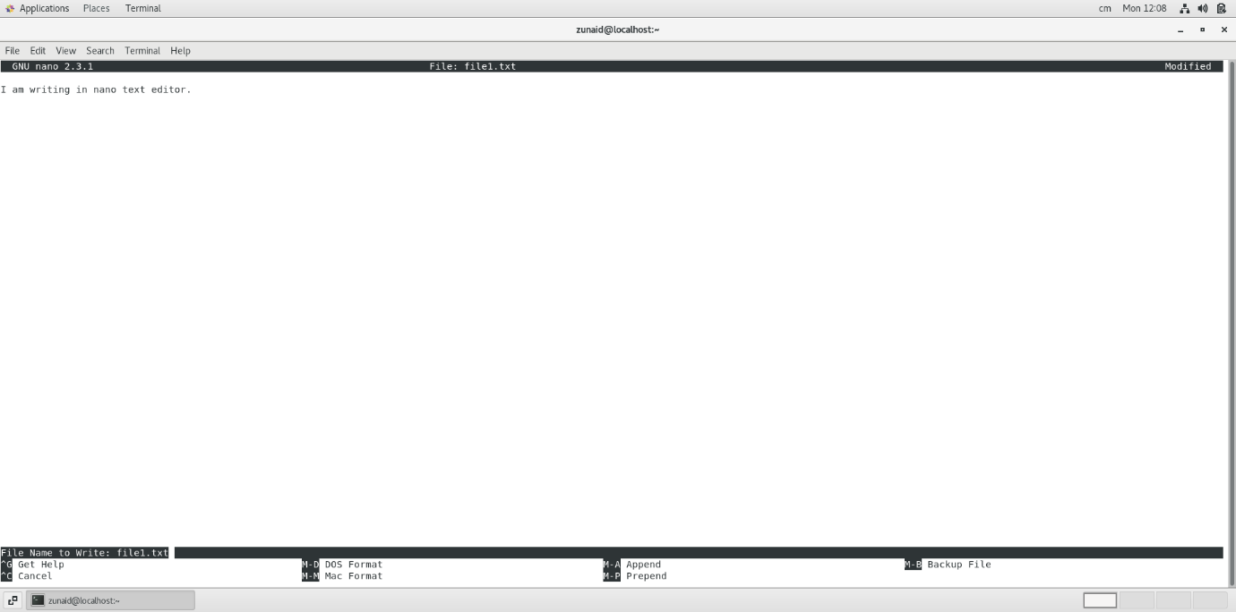

2. Now we will copy date from file1 to new file2

o cp file1.txt file2.txt

o Then see the output of file2.txt, cat file2.txt

o Give screenshot

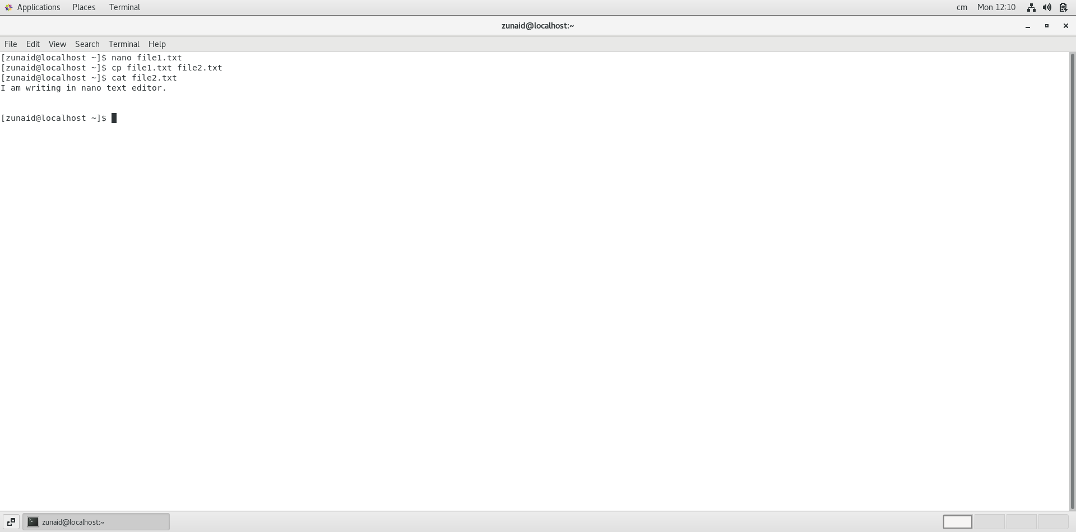

Step 1 : Type cp file1.txt file2.txt this will create the file2.txt and copy all the file1.txt to it.

Step 2: Type cat file2.txt this command concatenate files and print on the standard output

3. Now we will move the file2.txt to new folder /home

o mv file2.txt /home

o Then go to home directory and check ls, file exits or not?

o Given screenshot

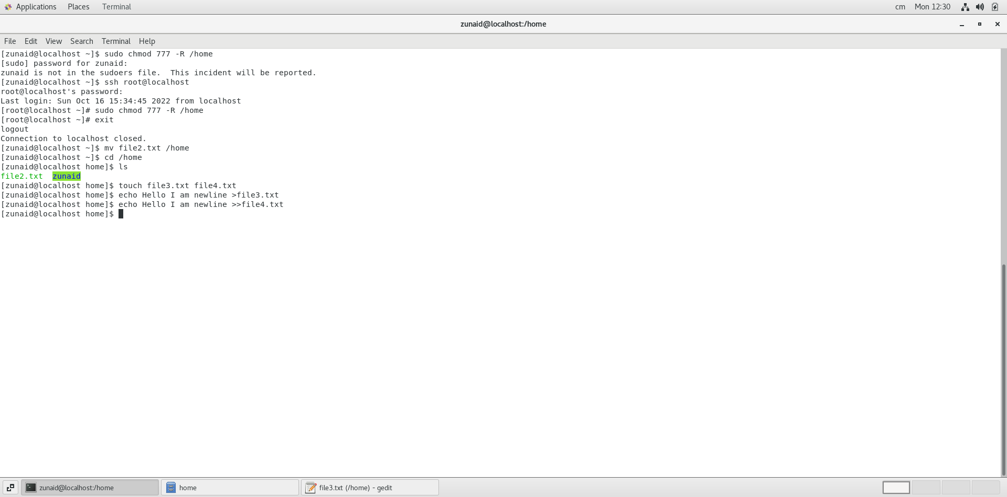

Step 1: before moving the file we have to change the permission of /home using sudo and chmod, ssh root@localhost command

Step 2: after that we can move file using mv file2.txt

Step 3: using ls printing the file/directories in /home

4. Then we create a new file3.txt and file4.txt in home directory and add

content in it.

o Now do echo “Hello I am newline” > file3.txt and provide the

output of file3.txt

o Now do echo “Hello I am newline” >> file4.txt and provide the

output of file4.txt

o Tell the different between both step you follow and the reason

behind it

Step 1: Using command touch file3.txt and file4.txt create 2 files

Step 2: after that using echo write the lines you want to write in the file



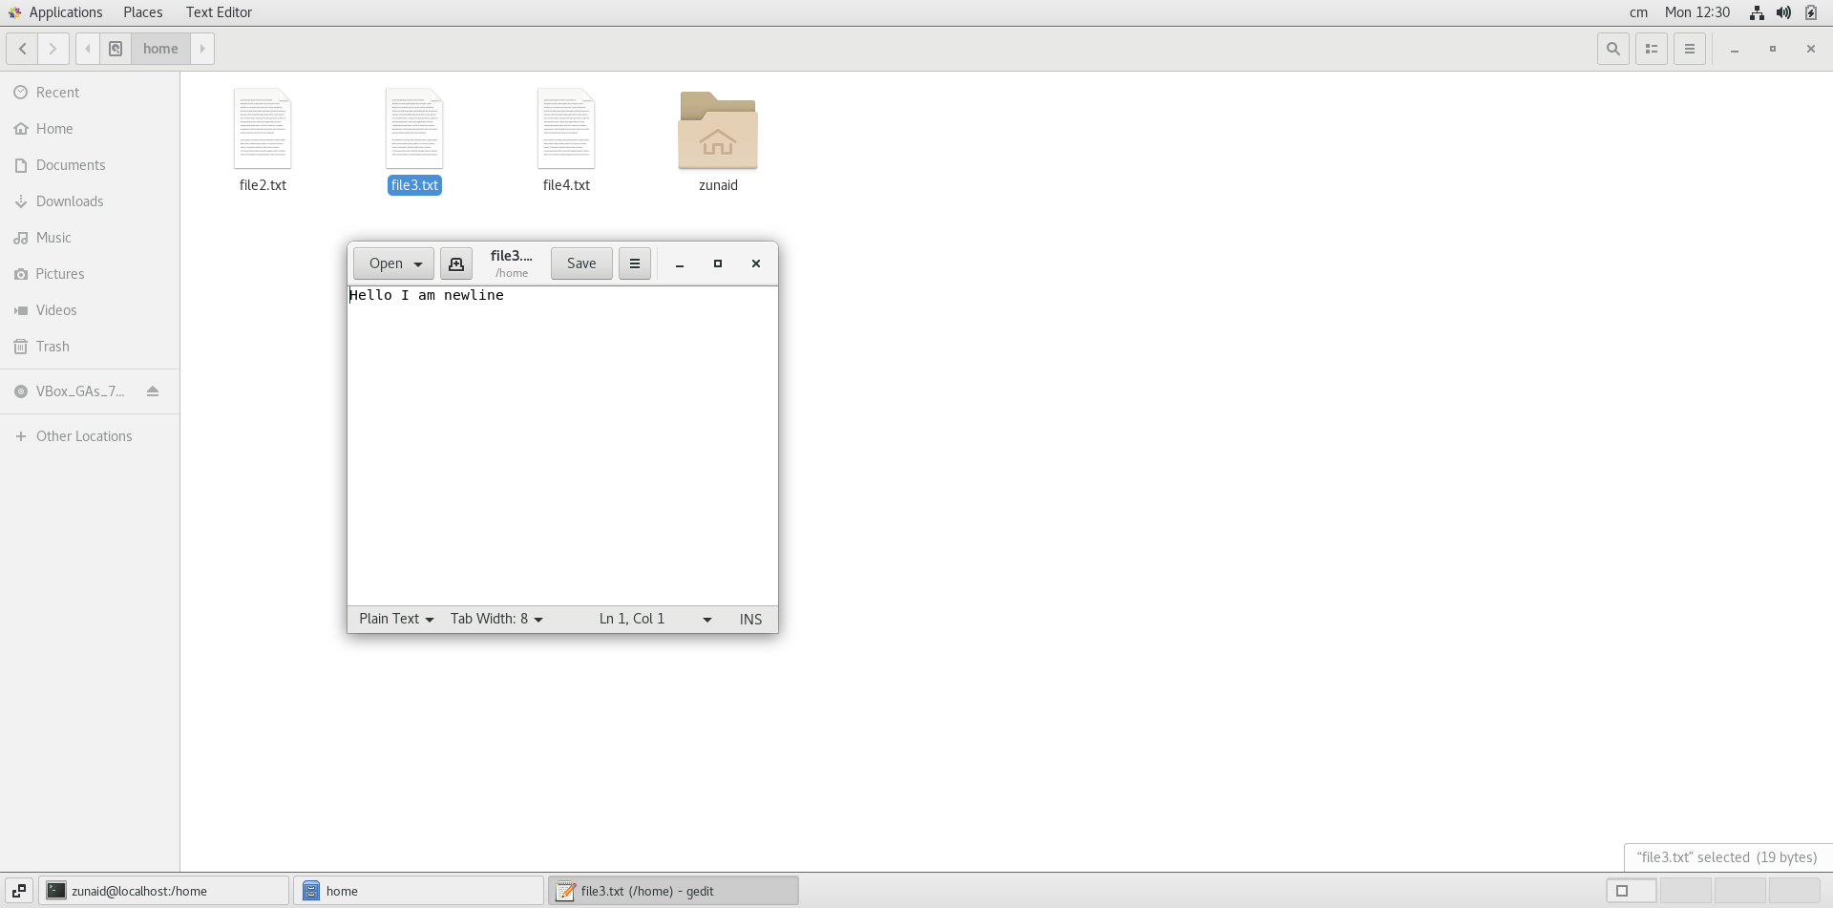

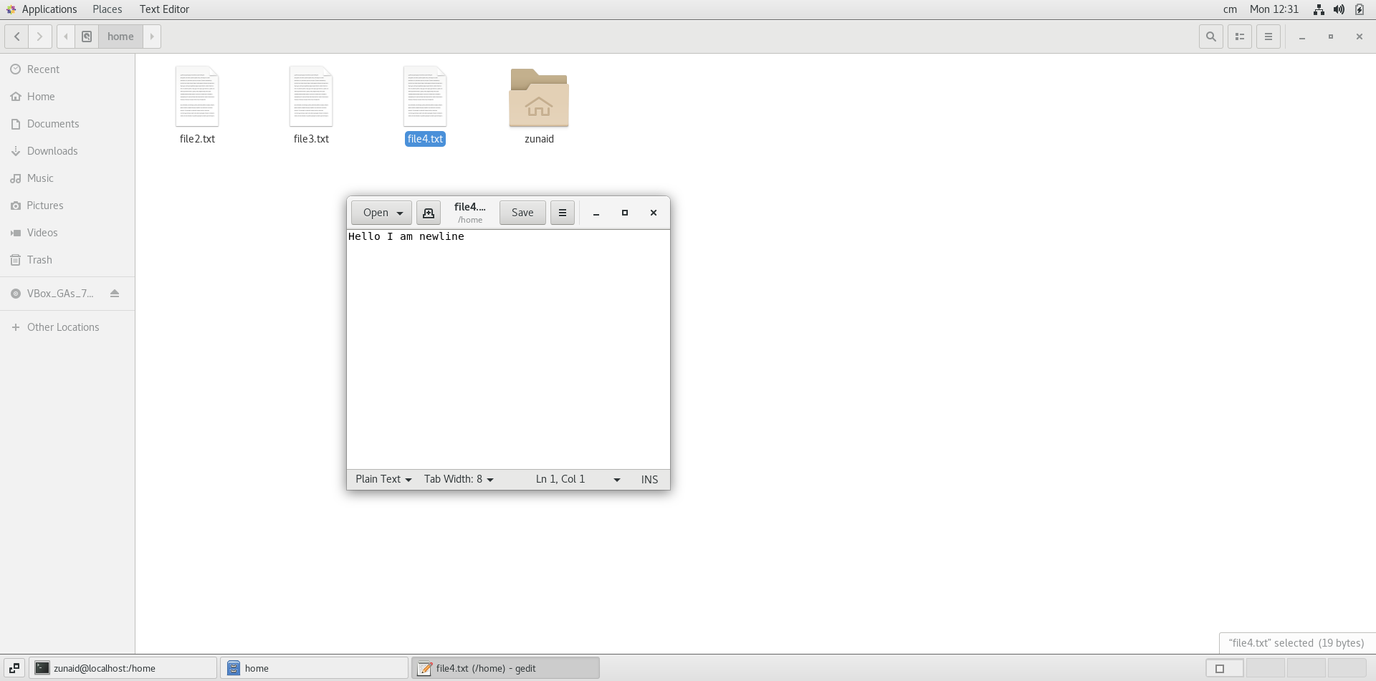

The main difference between echo “Hello” >file.txt and echo “Hello” >>file.txt is that

>this will rewrite inside the file remove the previous txt of the file

While >> will append the text in the file.

5. For remove a file or directory you can use the below two commands

o To delete a file – rm <any_filename>

o To delete a directory -rm <any_directoryname>

